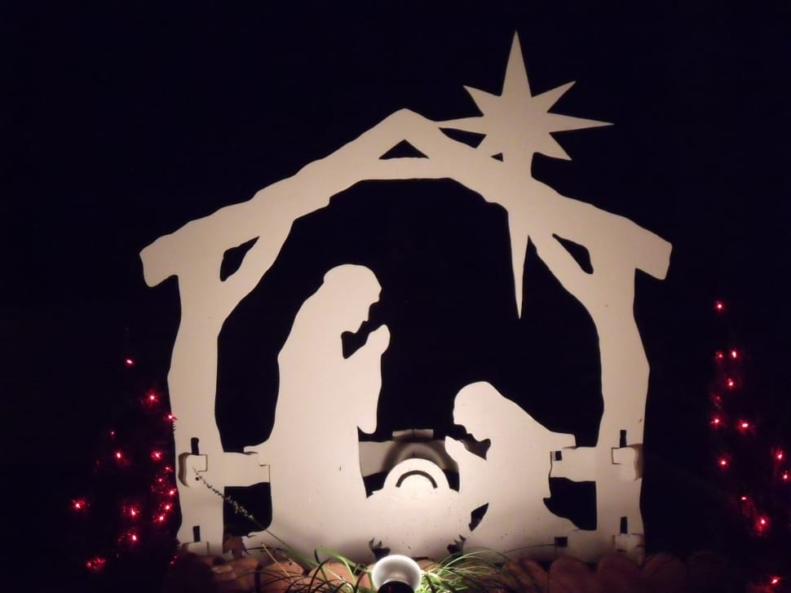
Hanging of the Greens
November 27, 2022
Bethlehem Lutheran Church
First Sunday in Advent

The Greeting and Announcements

Opening Prayer
The Meaning of the Service

Christmas Hymn: “Oh Come All Ye Faithful” verses 1-4

Reading: The Christmas Poinsettia

(Poinsettias are brought in)

The Call to Celebration

Responsive Reading *please stand*

Leader: For the time is coming; says the Lord when I will place a righteous branch upon King David’s throne.

Congregation: He shall be a King who shall rule with wisdom and justice, and cause righteousness to prevail everywhere throughout the earth.

Leader: For unto us a Child is born; unto us a Son is given; and the government shall be upon His shoulder.

Congregation: These will be His royal titles: Wonderful, Counselor, The Mighty God, The Everlasting Father, The Prince of Peace.

Leader: His ever-expanding, peaceful government will never end. He will rule with perfect fairness and justice from the throne of His Father.

Congregation: He will bring true justice and peace to all the nations of the world. This is going to happen because the Lord of Heaven has dedicated Himself to do it!

Leader: And Christ became a human being and lived here on Earth among us and was full of loving faithfulness and truth.

All: Let us praise God that the light of Christ shines on in the darkness, which has never overcome it. To God be the glory in Jesus Christ and in the church forever and ever. Amen.

Invocation in unison

Gracious God, Ruler of the Universe, Author of Life, we come into Your presence today to make our preparations for the birth of the Christ Child. Fill us with Your love and open our hearts so we may behold the wonder of Your great gift of salvation. Amen.
Christmas Hymn: “Go Tell it on the Mountain”
(Wreaths are hung on windows)
Reading: The Sanctuary Evergreens

THE PROPHECY
Scripture: Mark 1:1-3
(Lighting of the Advent Candle)
Reading: Advent Wreath
Advent Hymn: “Come thou Long Expected Jesus” verses 1&2

THE ANNUNCIATION
Scripture Reader: Luke 1:26-35
Christmas Hymn: “It Came Upon a Midnight Clear” verses 1&2
(Lighting of altar candles)
Reading: Light

THE BIRTH
Scripture Reader: Luke 2:1-7
Christmas Hymn: “Silent Night, Holy Night”
(Nativity scene is set up)
Reading: Nativity Scene

THE SHEPHERD’S STORY
Scripture Reader: Luke 2:8-15
Christmas Hymn: “The First Noel” verses 1& 2

Reading: Christmas Caroling
Christmas Hymn: “Hark the Herald Angels Sing”

(Angels placed on trees)
Reading: Angels

Noisy Offering
Children’s Message
Message Pastor Eric

THE ADORATION
Scripture Reader: Luke 2:16-20
Christmas hymn: “Away in a Manger”
(Tree is lit)
Reading: Christmas tree and lights

THE COMING OF THE MAGI
Scripture Reader: Matthew 2:1-9
Christmas Hymn: We Three Kings verses 1&2
(Banners are hung)
Reading: Wise Men
OUR GIFT

Scripture Reader: Matthew 2:10-11
(Gift of “gold” are placed under tree)
Reading: Gifts

Offering
Reading
Christmas Hymn: “What Child is This”
(Baby Jesus is placed in the manger)

Prayer
The Blessing
Christmas Hymn: “Joy to the World”
*Please stand*

Thank You to all who participated and helped with our service today. We thank you for joining us today at Bethlehem, may this advent season prepare your heart and mind for the coming of our Lord and Savior. Blessings to you and yours.
Prayers for our Members and friends:
Harlan Melz Claire Stonebreaker
Deloris Steffensen Randy Melz
Brian Bashan Marcia Aukes
Christina Coughlin Carolyn Bartz
<<<memo>>>
Just some reminders:
NIB Tour of Lights-Live Nativity here on Dec 4th, at 5pm
Sunday School Christmas Program-Dec 18th, at 5pm
Christmas Eve service @4pm/ 10pm
Christmas Day service of Lessons and Carols-9:30am

December Ushers/Greeters
*4 Carter Wubben(c) Family and Linda Berhow
11 Laurie Buchs Family, Glenda Sapp and Willmert Family
18 Billy Jensvold Family and Maryls Dotseth
24 Tim Weaver Family and Jen McGrady
25 Dana Greensky Family and Shirley Hagenson

Poinsettias
We are donations to purchase more, if you would like to get one in memory of someone or donate, please see Jen or give her a call. They are 20.00.

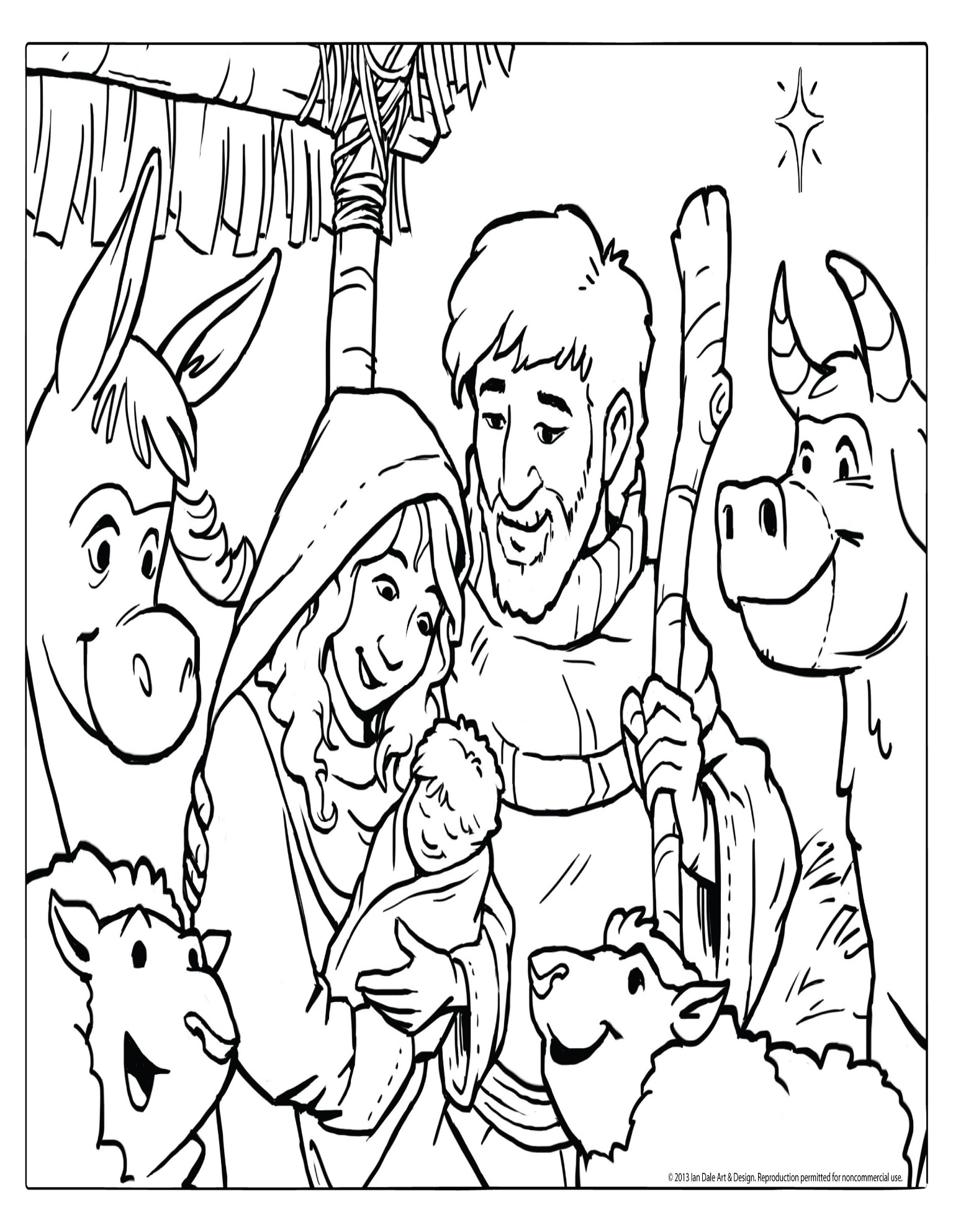
5r

